signInAuthenticationFailed1658954670834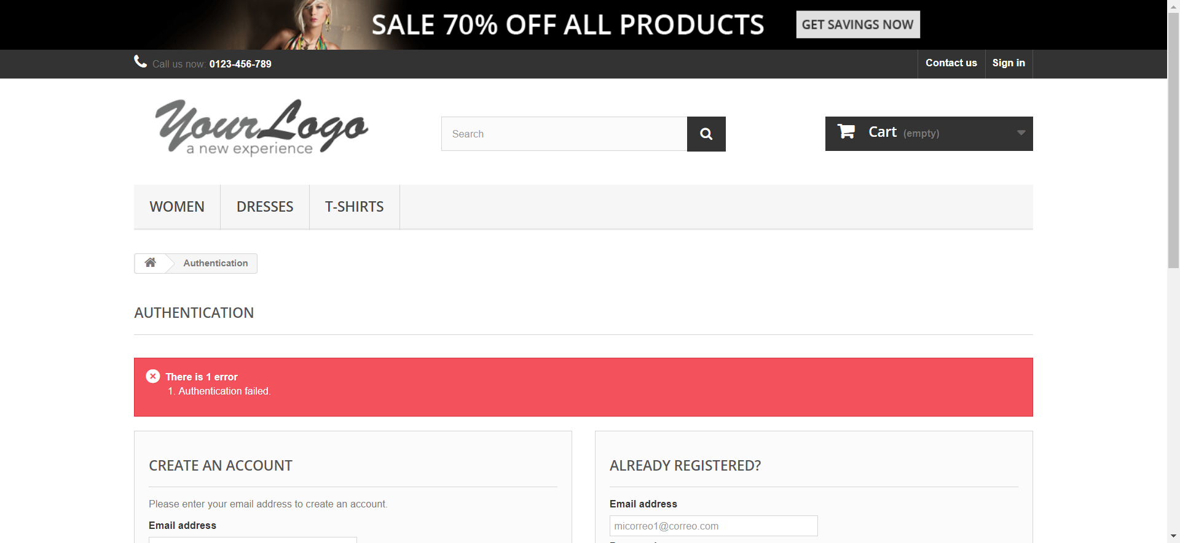

signInEmailInvalido1658954684879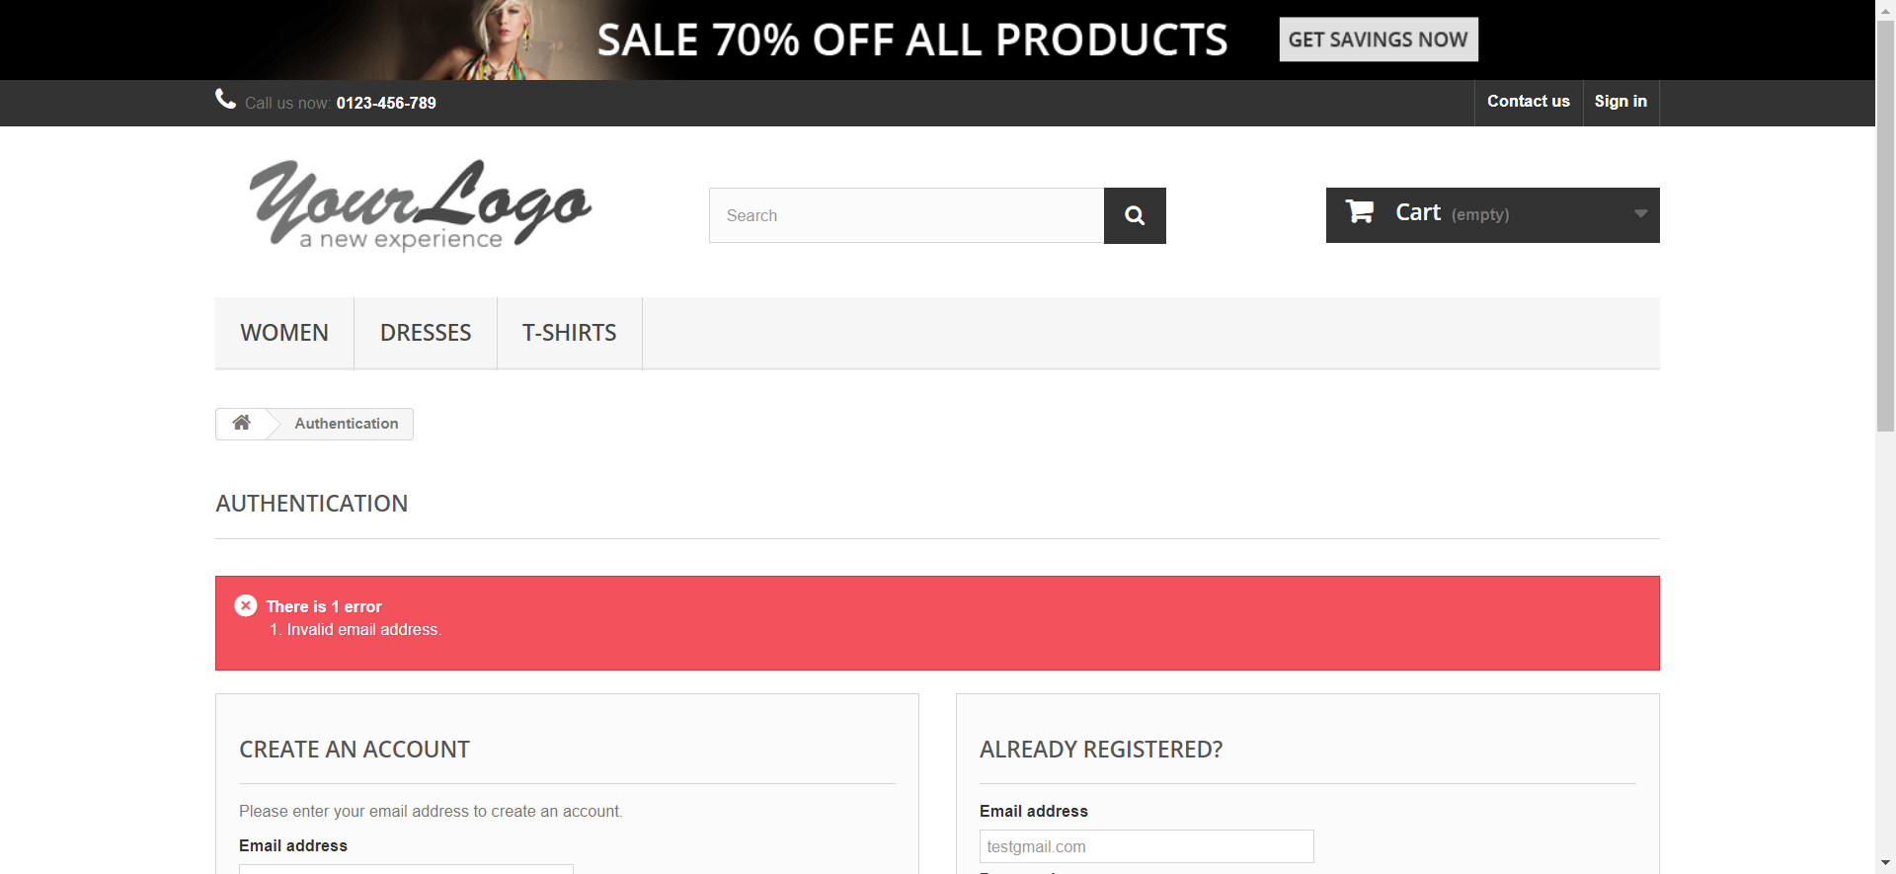

signInEmailInvalido1658954697559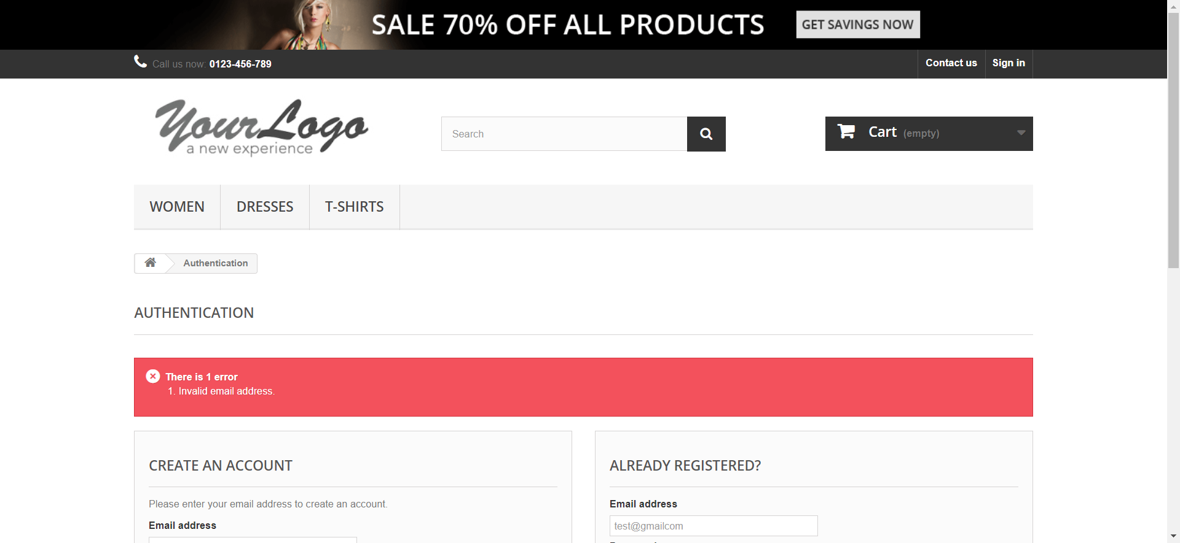

signInEmailInvalido1658954709796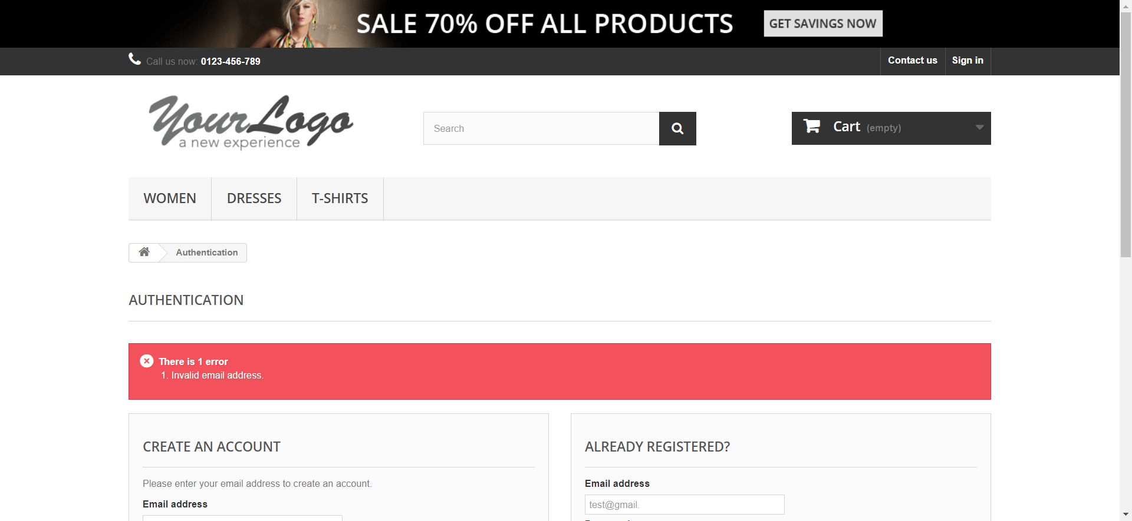

signInInvalidPassword1658954720215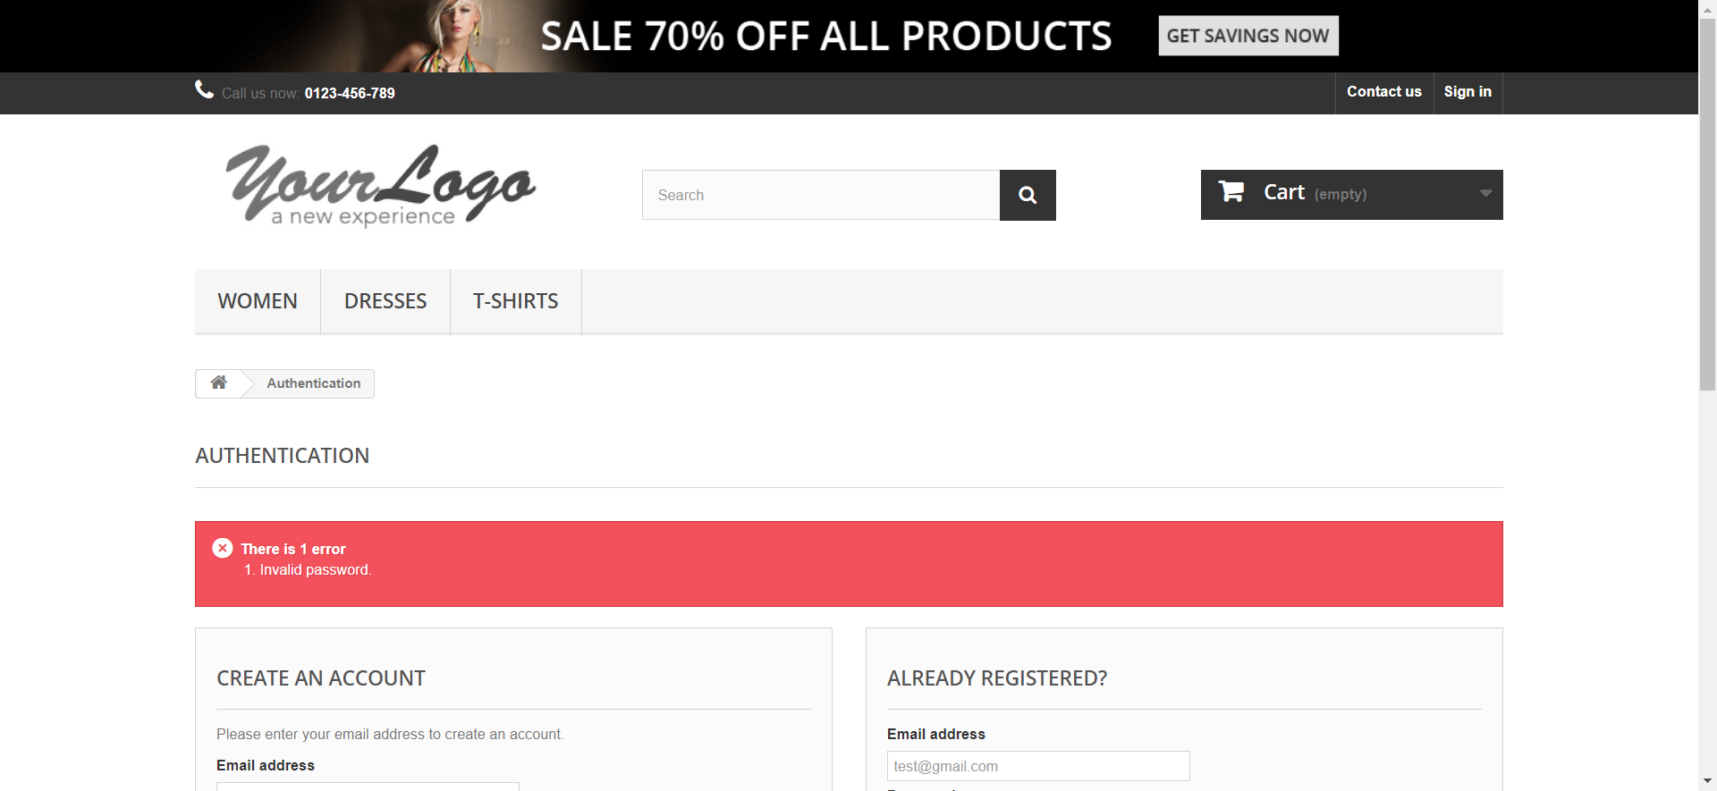

signInInvalidPassword1658954726511

signInInvalidPassword1658954734724

signInRequiredEmail1658954749610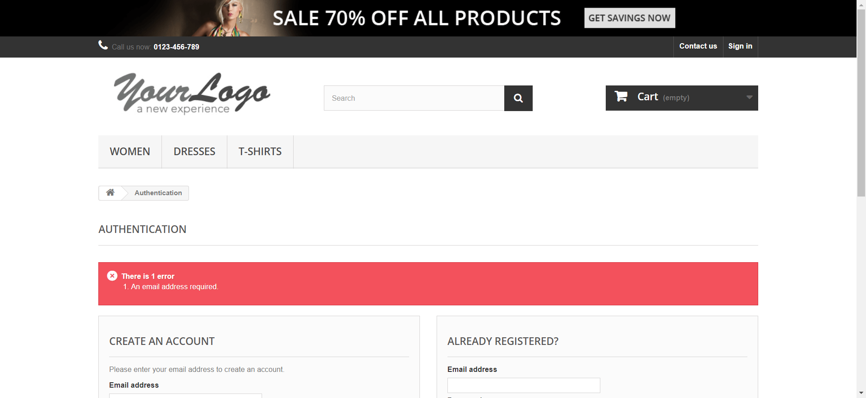

signInRequiredEmail1658954760464

signInRequiredEmail1658954771539

signInRequiredPassword1658954780195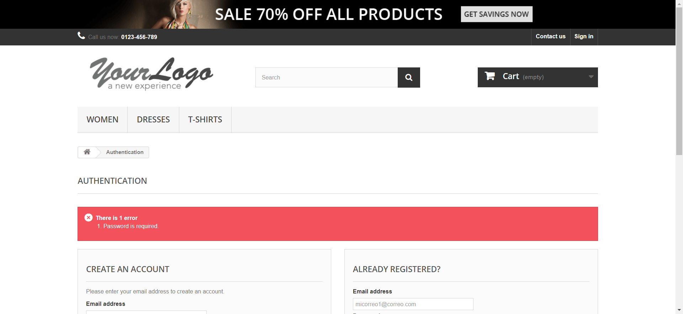

validSignIn1658954790128